Cookbook on integration & use
Introduction
The purpose of this document is to give producers and consumers of shared services, hands-on guidance. It includes step-by-step descriptions by including practical examples on real world scenarios regarding both integration as well as the actual adding of features to make a service more shareable.

TODO: Describe that this document is divided in two parts.
- Real life examples from the service development within the I3S project.
- Schoolbook examples with fictive services and scenarios.

Real examples of architecture decision making 2
Implementation of containerization 2
Precondition 3
Requirements 3
Portability 3
Features 3
Containerization 3
Architecture analysis → containerization ideas 4
Runtimes and platforms 4
Need for persistence 4
Services and their explicit boundaries / endpoints (inbound connectivity). 4
Dependencies (outbound connectivity) 5
Implementation result 6
Implementation of metadata driven validations with adaptors 6
Precondition 7
Requirements 7
Metadata driven 7
Features 7
Metadata Access 7
Adaptors 7
Service integration 8
Schoolbook examples of architecture decision making 10
Scenario 1 - From disconnected services to connected metadata driven 11
S1 Starting point 11
CAWI 11
ErrorLocalization 11
S1 Goals 11
S1 Thought process 12
S1 Result 12
Scenario 2 - Context Aware 13
S2 Starting point 13
S2 Goals 13
Scenario 3 - Revisiting integration pattern 14
S3 Starting point 14
Scenario 4 - Containers 15
Scenario 5 - Design driven information flow 15

Real examples of architecture decision making

Implementation of containerization
IS2 (a.k.a Relais) is a software for record linking, originally developed by ISTAT. This chapter describes and discusses the process of containerizing this software using Docker.

Precondition
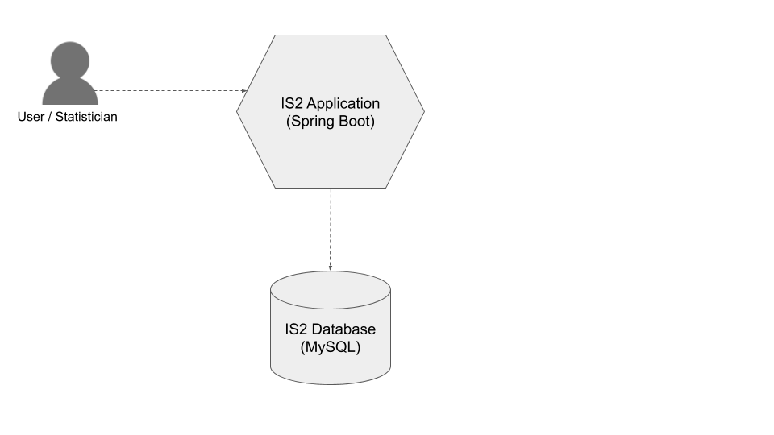
The IS2 solution consists of a web application that serves web browser user interaction and a RDBMS for storage of application state. IS2 Application is a Java web application based on Spring Boot and the databases is a MySQL database.

Requirements

Portability
Portability is the ability to easily move a service or system between different computing environment.
A containerized application can more easily be sandboxed in the purpose of service consumer exploration.

Features
The requirements are addressed with the following features.

Containerization
For a service to be executable in any computing environment the concept of containers should be used. Dependencies on underlying technology and infrastructure are eliminated which increases the number of hosting options for service consumers. This allows for cloud hosting as well as on-premise infrastructure alternatives.

Architecture analysis → containerization ideas
To be able to identify possible container decomposition and prepare the solution for containerization a series of architectural perspectives must be analyzed.
TODO: Mention: Good architecture, Sep of concerns, autonomy, statelessness

Runtimes and platforms
The solution has two distinct processes, one for the business logic (IS2 application) and one for the database (IS2 database). They are two totally different kinds of software with very different footprints in terms of CPU and memory usage.

💬 One container for the application and one for the database is most probably an appropriate container decomposition.

Need for persistence
Error- and other runtime log information generated by the IS2 application must be persisted.
Main application state is stored in the IS2 database.

💬 For the application container to have persistent storage of log files, a Docker Volume can be mounted to the container.
The database is put in it’s own container and is an optional part of a deployed solution. Based on the preferences of the service consumer, the database layer could instead be configured to run in some other storage solution (cloud or on-premise). Database containers must also have persistent storage mounted to them.

Services and their explicit boundaries / endpoints (inbound connectivity).
Users/consumers interact with the the solution solely through web pages served by the IS2 application. In the future it is likely that API:s may be exposed from the application as well.
The database is a private resource for the application.

💬 Ports for accessing the application container must be properly exposed outside of the container host environment. The database container must expose ports to allow for the application to access it.

Dependencies (outbound connectivity)
The application has a strong dependency to the database. The location of the database is stored in application settings config. For the application to work the database must be available.

💬 Location of the database must be configurable from outside of the container. Other things to consider is the level of resiliency to temporal unavailability of external dependencies - the application must be able to recover gracefully from a non responsive database connection.

Implementation result

Docker
Resulting physical architecture
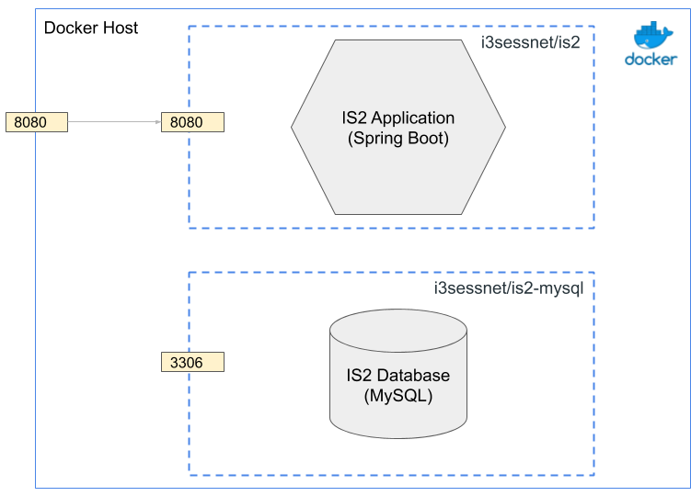

Container 1: Application
Base Docker image: OpenJDK
Container 2: Database
Base Docker image: MySql

Startup dependencies caused problems. Current Relais depend too strong on a working database connection during startup (and perhaps later on as well). It is not resilient to temporal database unavailability.

Implementation of metadata driven validations with adaptors
In this scenario we want to use VTL to do validation in ARC and POGUES. We want to be able to use the same VTL expressions in both system. We will use the adaptor pattern to extend ARC an POGUES with an existing VTL engine through sharing. This means that we want to extend ARC and POGUES with some new features.

Precondition
TODO: Describe the systems.

Requirements

Metadata driven
Besides the input and output of services, there is often also configuration involved which determines how the services behave. Part of this configuration might be statistical and/or metadata related in nature, like the identificator of the statistical program or survey, sample sizes, collection modes, classifications and code lists, etcetera. The model of this metadata is given by GSIM. In this way, we can make use of existing metadata and services will become easier to integrate into the statistical organisation.

In this case we want:

- to use the same validation rules for administrative data and questionnaires.
- to execute the VTL-rules in runtime for validation.
- to be able to edit the validation i a common tools.

Features
The requirements are addressed with the following features.

Metadata Access
Metadata is used and produced during all phases of a particular statistical process. In consequence, CSPA services that participate to those activities should be able to process and produce metadata using standard APIs and formats. Metadata in a CSPA Service should use open standards like GSBPM, GSIM, LIM and VTL if possible.

In this case we want:
- We want to use VTL, (XML, JSON) as the language to be able to express and validate the rules to be able to share a common language between services.

Adaptors
In this use case we want to expand the functionality of the current VTL-engine to have a more standardised way of validation syntax. This means that we will build a component that uses BNF.

In the picture below we show the VTL parts that will be built.
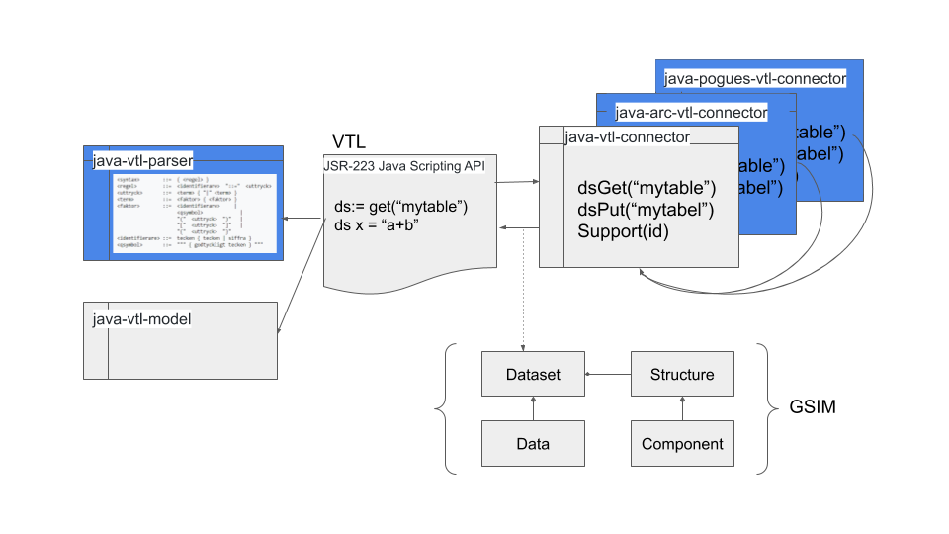
We will build two connectors, one for POGUES and one for ARC. Generate a grammar file to use for the new BNF component.

- We need to develop the connector to the metadata strukture in ARC (Blue).
- We need to develop the connector to the medatada strukture in POGUES
- We need to develop the component to read the grammar file(blue)
- We need to create a react control for highlining

Service integration
Reuse of components no integration pattern is used. The system view should lock like this. The ARC system uses the same VTL code but uses its own interface for the connector.
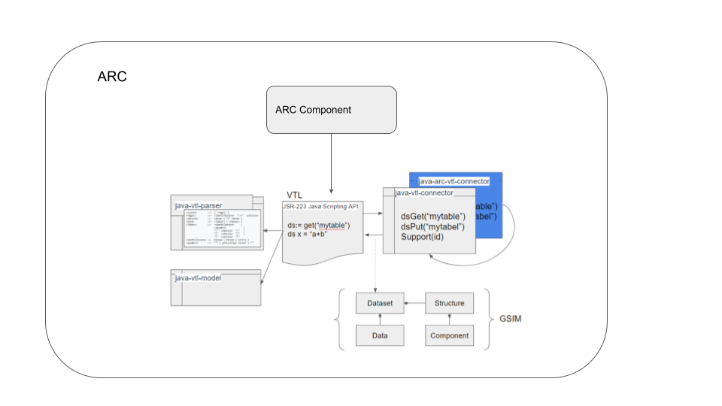
As we can see in the image the the same code is reused in the POGUES system with its own connector.
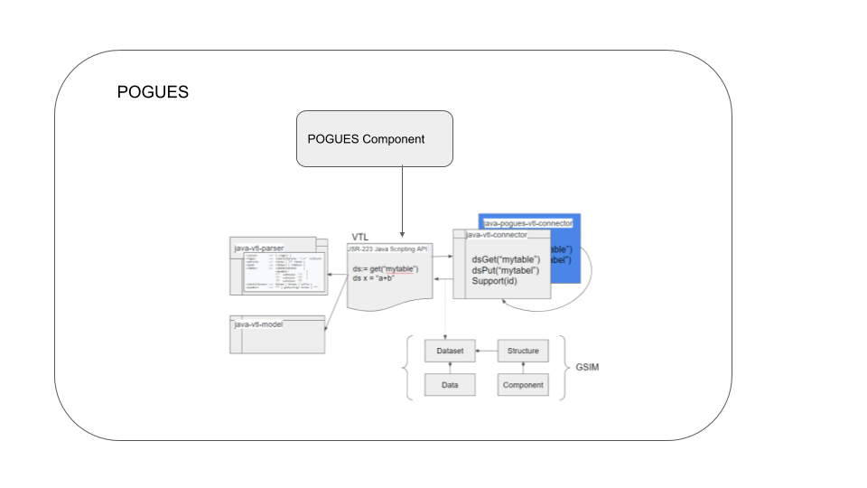

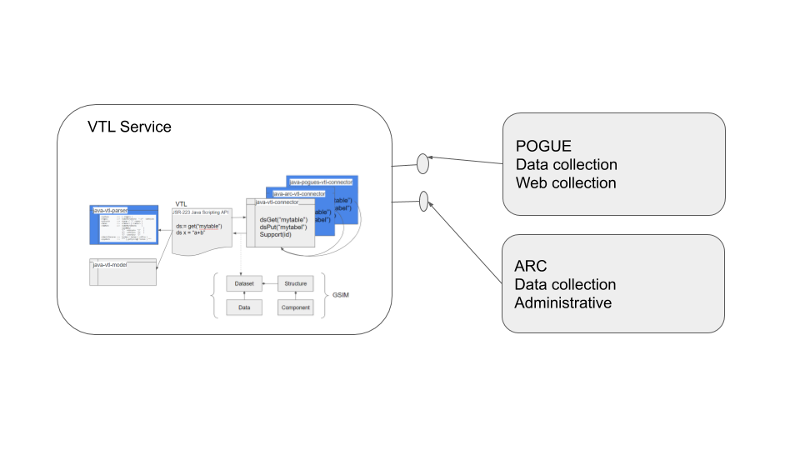

Schoolbook examples of architecture decision making
In each scenario we try to show a current state of a system, an identified flaw, and how we can amend this with a remodelling of the architecture.
This repository is created to help developers and architects view examples of features applied into services. The scenarios describe different states your environment could be in, and examples how to gain a more recommended state using architecture described in CSPA.
Taking small steps and adding value incrementally. Trying not to overreach in our examples we strafe for taking small logical steps to evolve our services. This is why in our examples might take tideous small steps in advancing the architecture of the system.

Scenario 1 - From disconnected services to connected metadata driven

S1 Starting point
We start with two services (CAWI, ErrorLocalization). CAWI is a web based tool for taking surveys. ErrorLocalization is a service that can flag answers as faulty based on a rule set. The services or application do not know of each other, each has implemented its own implementation of a code list. Therefor each service need logic for handling of the codes lists used.

CAWI
TODO: Describe system

ErrorLocalization
Is a service that flags errors in the answer collection.
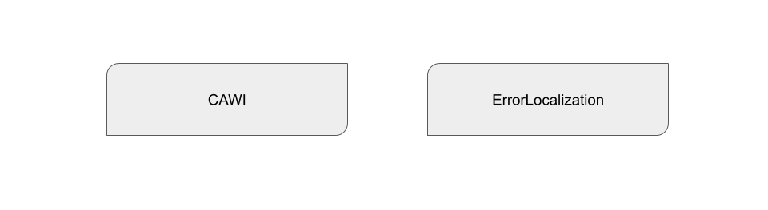
Code is found here: Code Scenario 1

S1 Goals
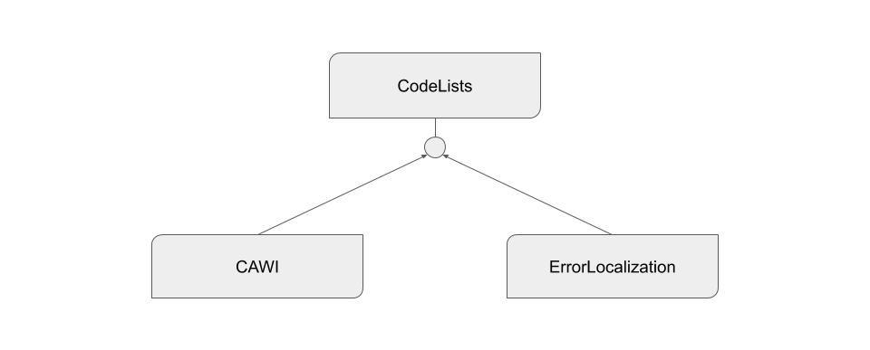
To follow principle of metadata driven systems, we see that each of the two services needs to manage the same meta data. By extracting this function we can make each service be more accomodated towards single responsibility. Thus lowering the manual labour keeping two systems up to date with the same data.

S1 Thought process
By extracting the handling of metadata to separate service we create a single point of thruth regarding data consistency.

S1 Result
Having a disconnected state of applications the manual labour to keep data up to date is high. The risk of poor data integrity is high. By extracting logic of manupilating the codelist metadata we have lowered the cost of keeping data up to date. We have now a masterdata repository who is owner of its data.

Scenario 2 - Context Aware
We have the three services CAWI, CodeList, and ErrorLoc but we have identified they use the same meta information in some regard. The dupication of information is therefore a fact. By making the services context aware we can extract logic regarding setting up dupicate meta information in the applications.
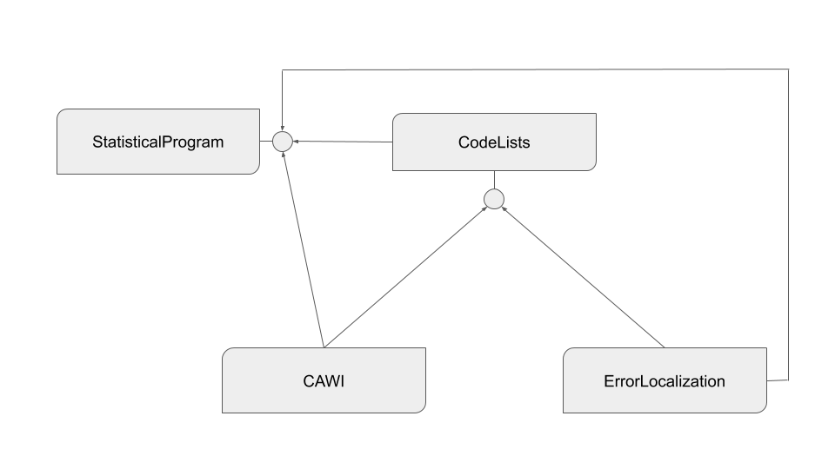

S2 Starting point
We start off by having three services; CAWI, CodeList and ErrorLoc as described above. However each service is defined for a specific statistical program, therefor a few implementations of similar services starts to pop up with the similar implementations.

S2 Goals
By extracting a service for handling meta data regarding Statistical programs we can minimize the duplication of manual setup within each service.

Scenario 3 - Revisiting integration pattern
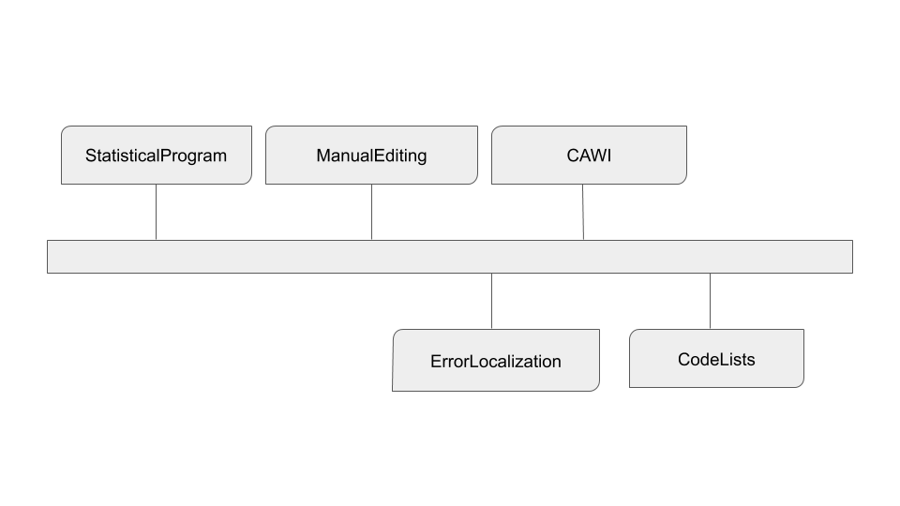

S3 Starting point

Scenario 4 - Containers
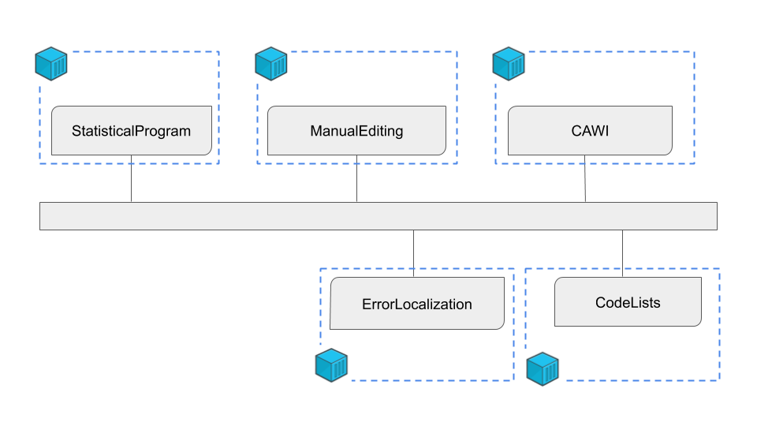

Scenario 5 - Design driven information flow
